|  |
| --- |
| **Activity 2** |
| **Software Deployment** |
| DVD Search Application |

|  |
| --- |
| Jose Rico Imbang  05/12/2020 |

# TABLE OF CONTENTS

Installation Requirements 1

Installation Method 2

Installation Plan 3

Creation of Installation Package 4

Database Deployment 8

Creating the .sql file 11

Install 12

Uninstall 12

Application Configuration 13

Security Feature 14

## Installation Requirements

The computers’ minimum hardware specification that is required to run the application are the following:

|  |  |
| --- | --- |
| Processor | 1 GHz |
| Memory | 2 GB |
| Storage | 32 GB |
| Graphics card | DirectX 9 or later with WDDM 1.0 driver |
| Display | 800 x 600 |

The hardware specification of the client’s system (My PC) meets and exceeds the minimum requirement. The hardware specification of the client’s system are the following:

|  |  |
| --- | --- |
| Processor | 2.5 GHz |
| Memory | 8 GB |
| Storage | 512 GB |
| Graphics card | Nvidia 940MX |
| Display | 1920 x 1080 |

## Installation Method

The installation method that will be implemented for this project is through an Executable JAR file. The name of the executable file will be MovieSearchApp.jar.

## Installation Plan

A .jar file will be created and it will be installed to the client’s PC. An .sql file will also be produced so it will be easy to just import the .sql file using phpMyAdmin interface. XAMPP will be installed into the client’s PC to be able to use phpMyAdmin and MySQL. JDBC driver will also be included in the application and is added to the classpath. Once these are all done, the client can just open the .jar executable file and use the application.

## Creation of Installation Package

Once the program is done, it is ready to be installed. Follow these steps to create an installation package.

* Open the project using NetBeans IDE.

*Note: If you don’t have NetBeans,* [*Click here to go to NetBeans website*](https://netbeans.org/) *and download NetBeans IDE binary zip file. Once downloaded, extract the file in your personal directory (e.g. My Documents folder). Run the netbeans64.exe (for 64 bit platform).*

* In NetBeans, open MovieSearchApp.java.

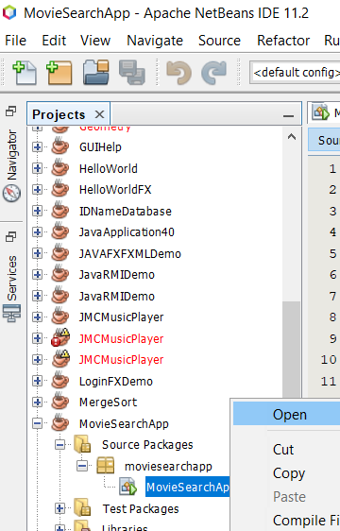

* Right click on the MovieSearchApp project and click Properties.

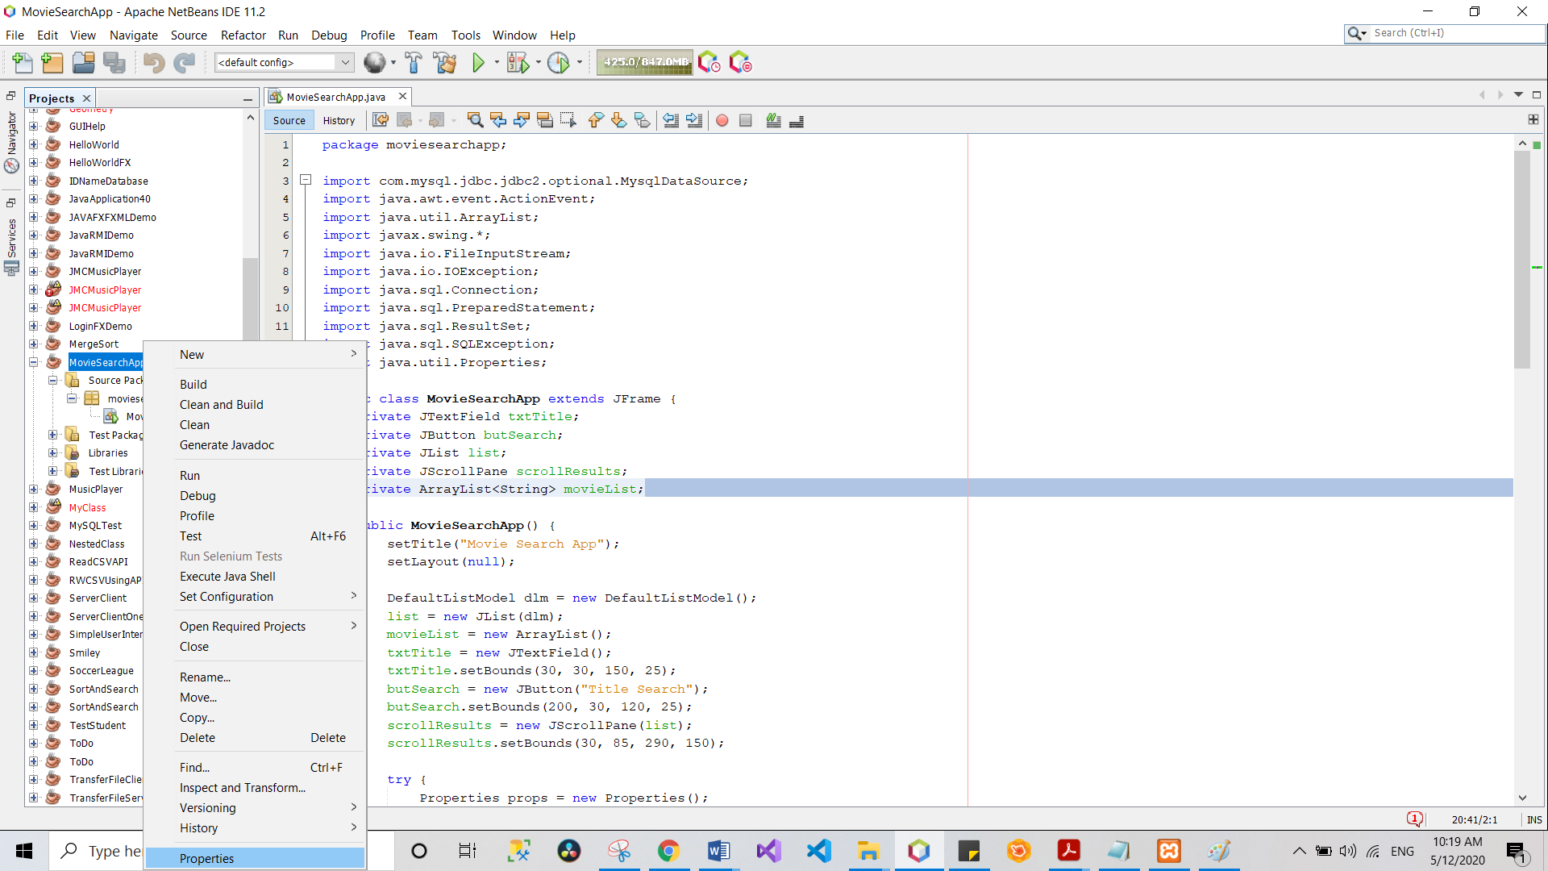

* Project Properties window will show up. Select Packaging then tick Build JAR after Compiling and Copy Dependent Libraries checkboxes.

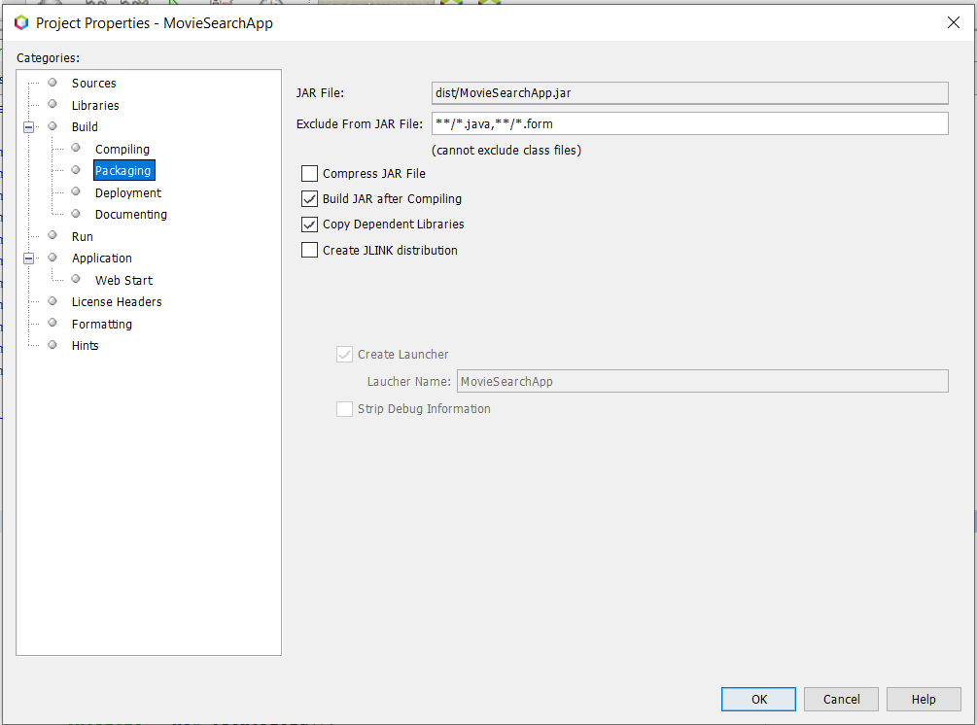

* Make sure that the form that you want to run first will run first. To do this, click Run on the left side of the Project Properties window then click Browse button and select the class the you want to run first the click OK.

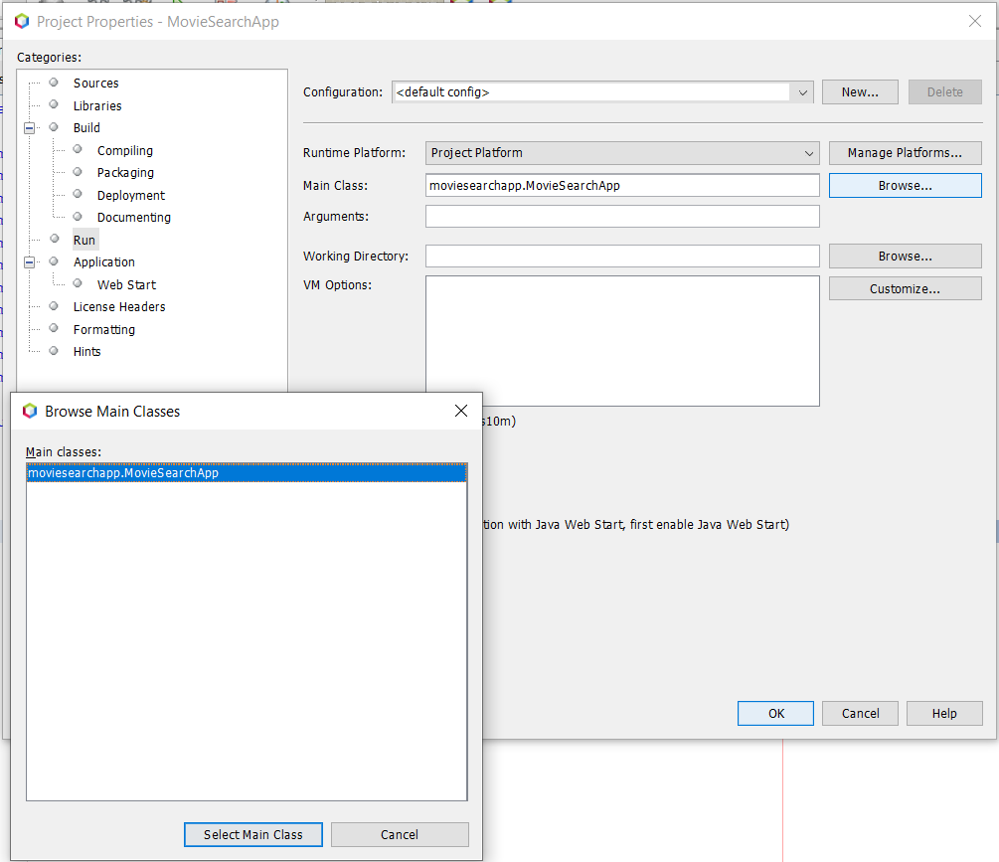

* Right click on the project then select Clean and Build.

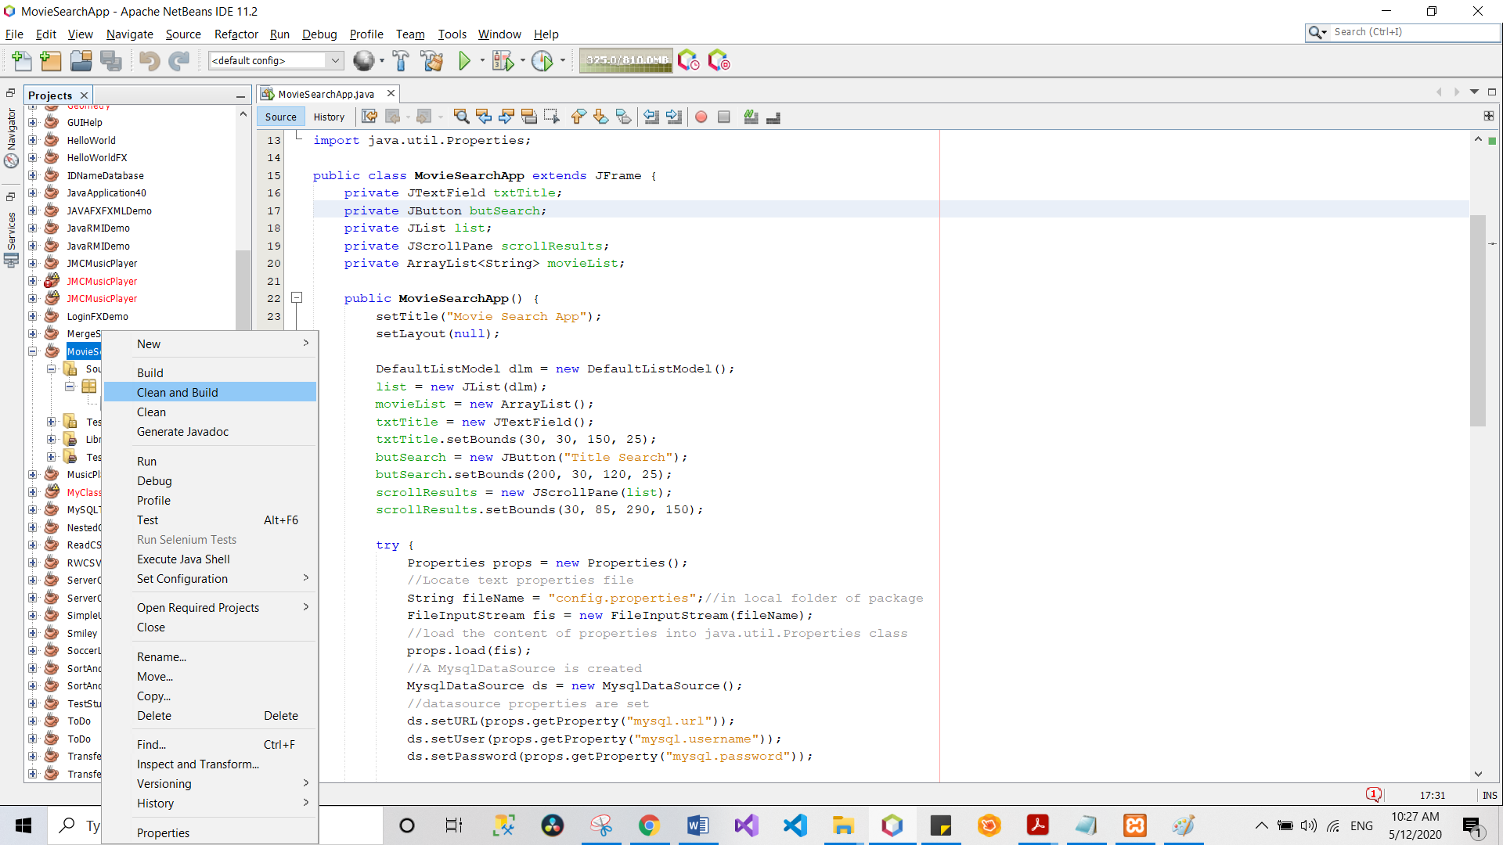

* You will see on the Output tab that a .jar file is created.

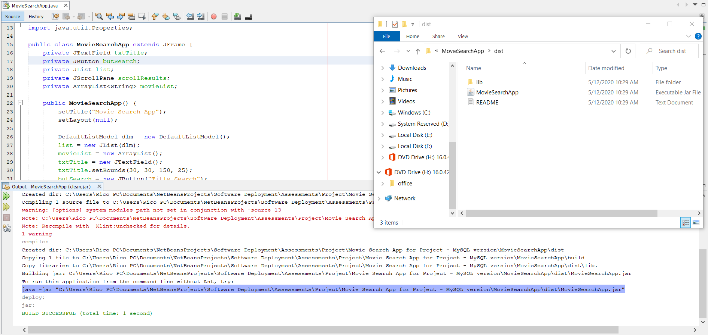

* You can simply open the .jar file to see if it works.

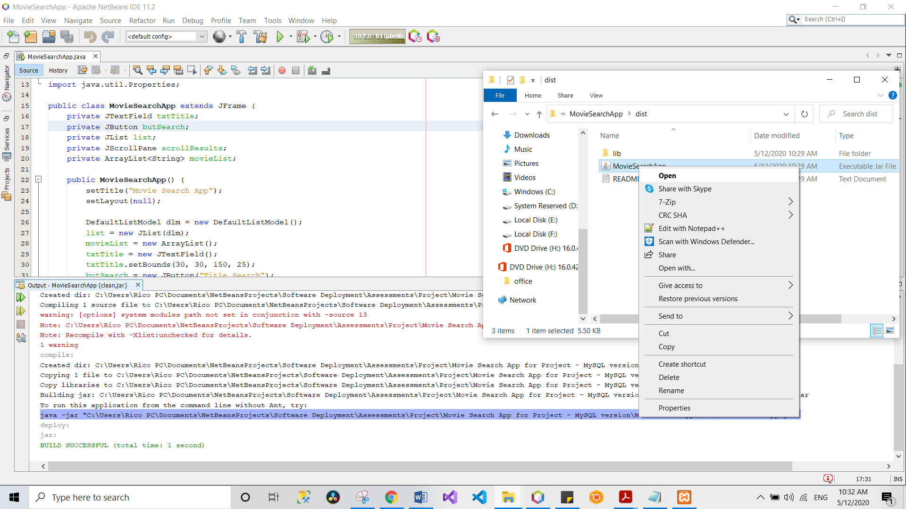

## Database Deployment

* XAMPP or a similar software needs to be installed in the client’s computer to be able to use MySQL. [Click here to download XAMPP.](https://www.apachefriends.org/download.html)
* Once installed, open XAMPP then start Apache and MySQL.

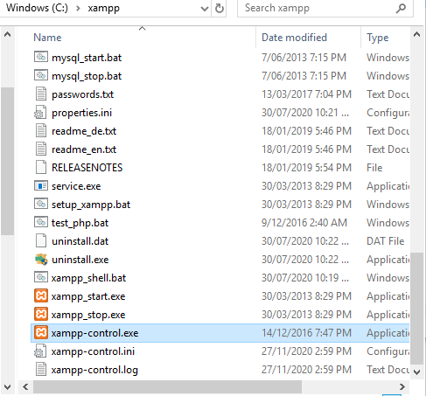

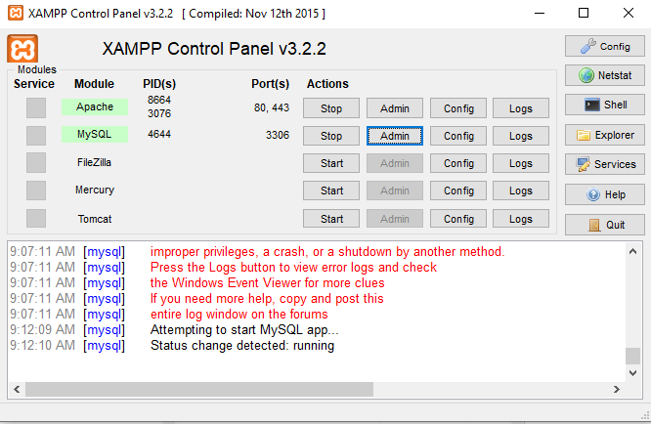

* Clicking Admin button will load phpMyAdmin.

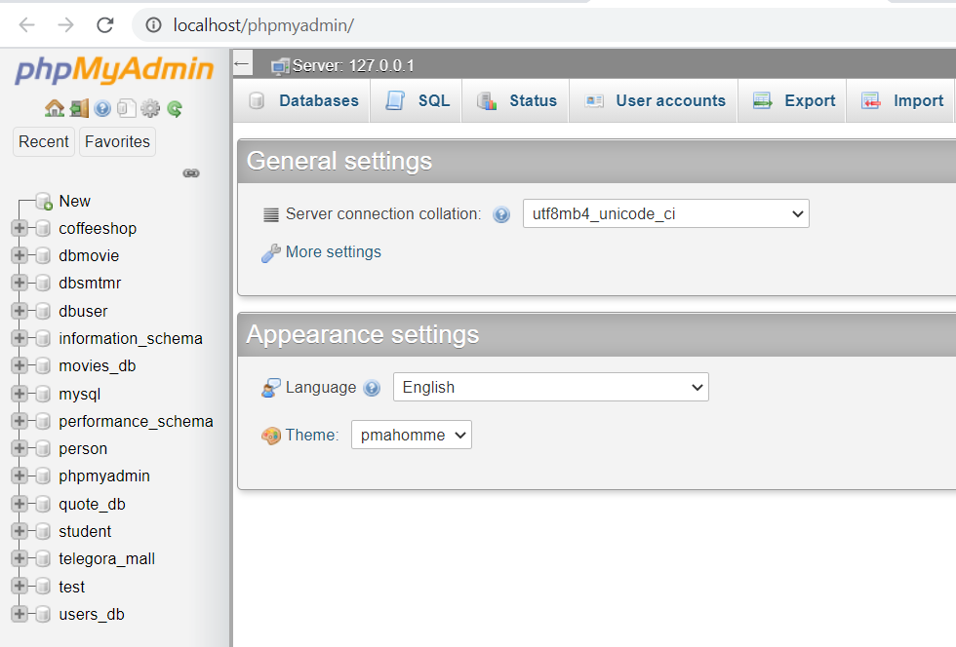

* Click Import button on phpMyAdmin interface and click Choose File button and look for your SQL file, click Ok then click Go button. Notice that dvd_titles database is not set up.

*Note: To create an .sql file, please go to the next section.*

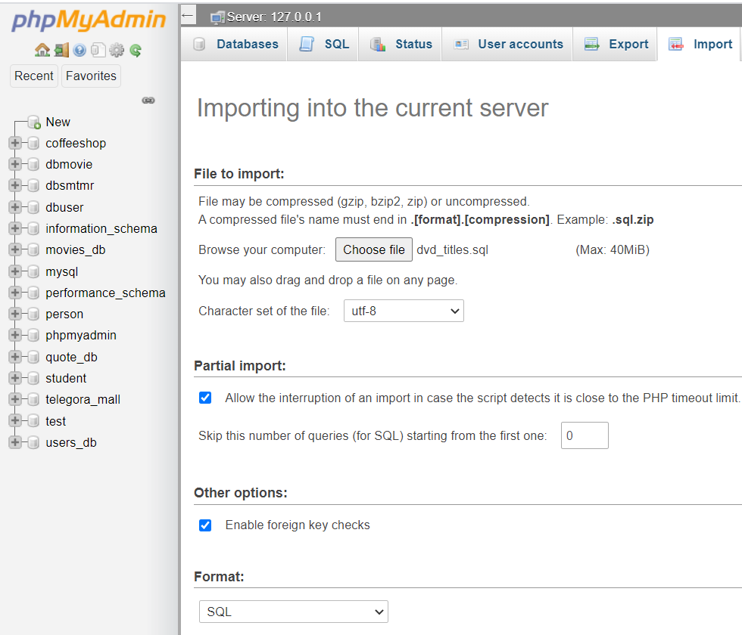

* *Import has been successfully finished* message will be shown if it is successful. You’ll also see the dvd_titles database is added to the left side of the interface.

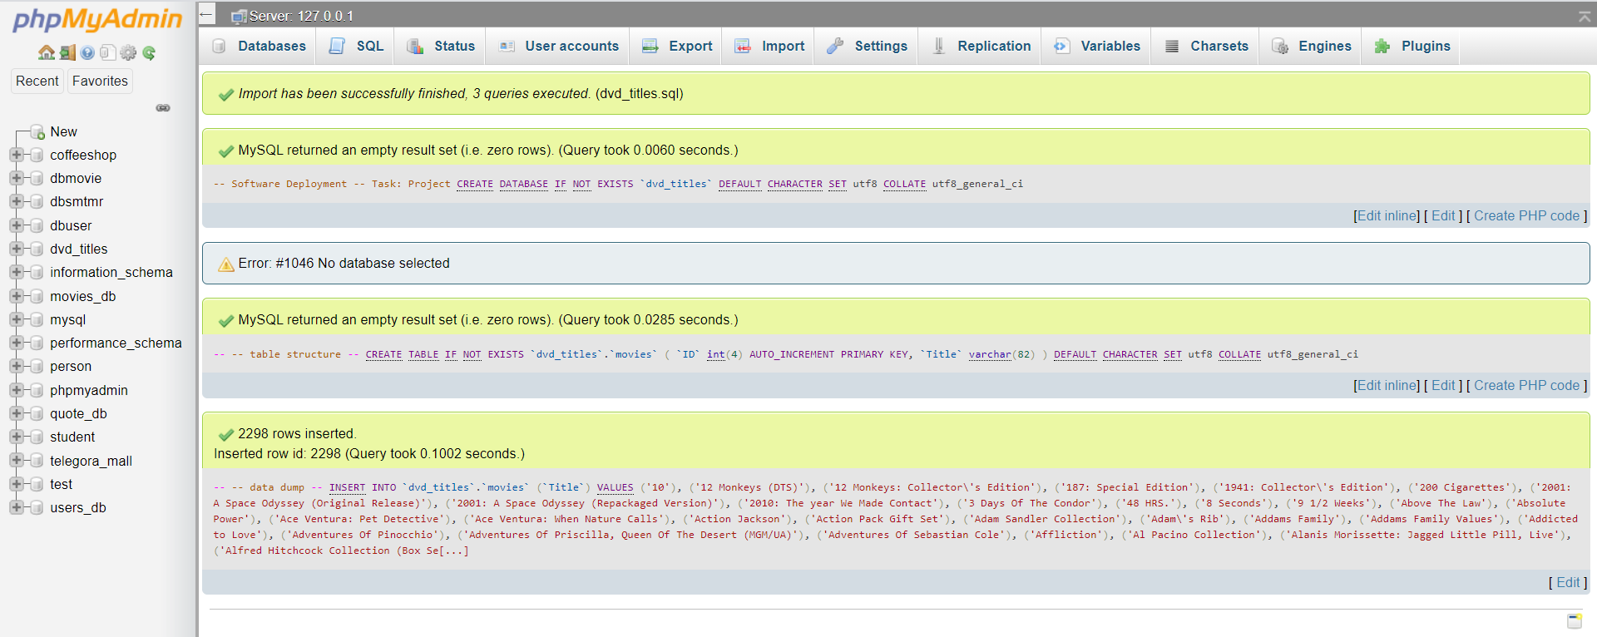

* Selecting dvd_titles database then movies table will show all the information.

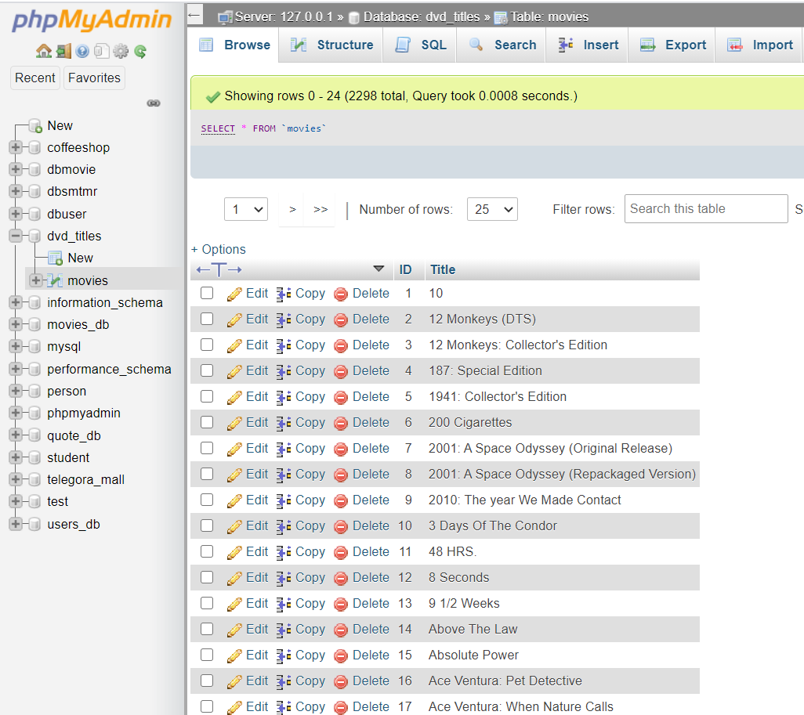

## Creating the .sql file

Select the database then click Export button. Click Go and the .sql file should be created.

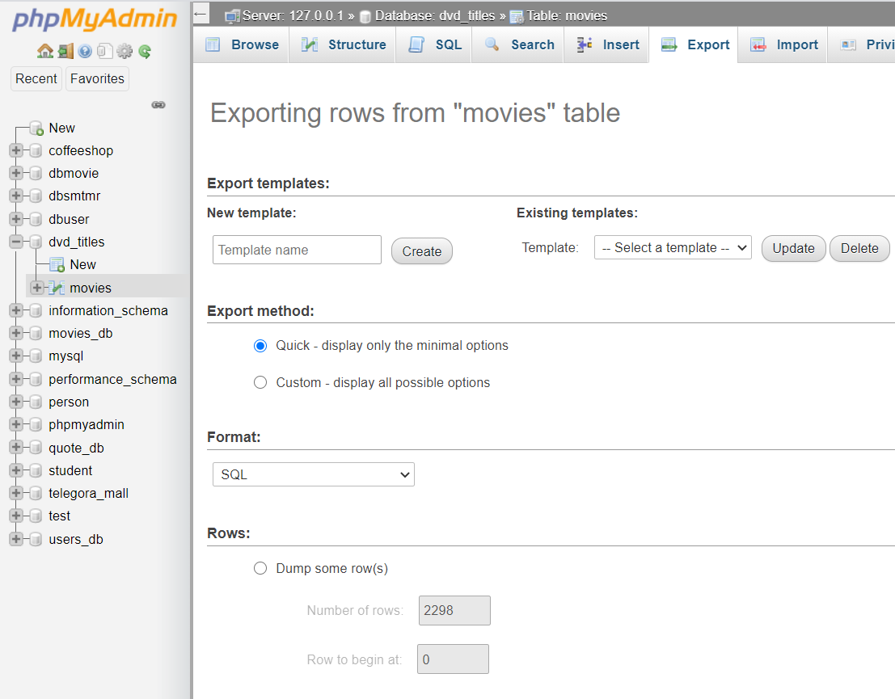

## Install

Installing the application is as easy as copying the .jar executable file and pasting it into the client’s PC.



## Uninstall

To uninstall the application, simply delete the .jar executable file.

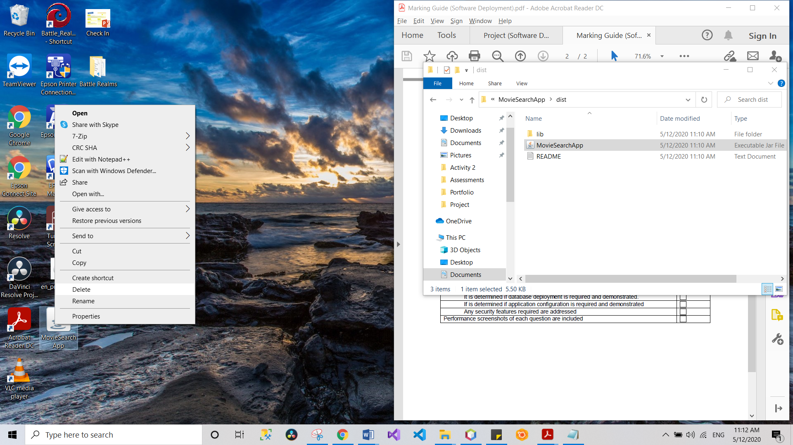

## Application Configuration

A .properties file is included in the project named config.properties. It contains the key-value pair for the JDBC driver, url, username, and password.

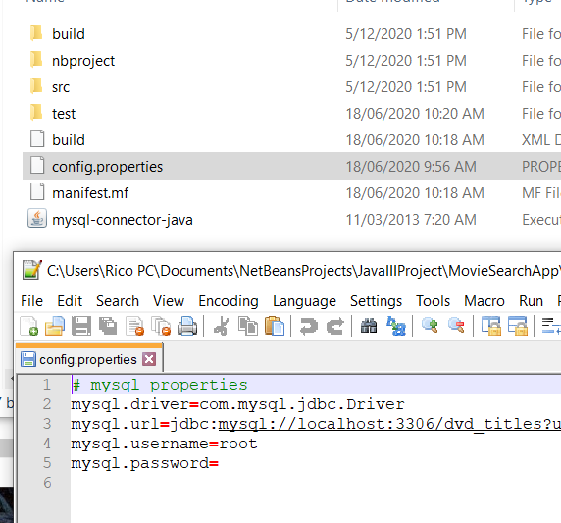

## Security Feature

It is recommended to save the executable file somewhere in Drive C (e.g. in Documents folder). This is to ensure that only the users with Administrator access can make changes into the application that may affect other users of the computer.